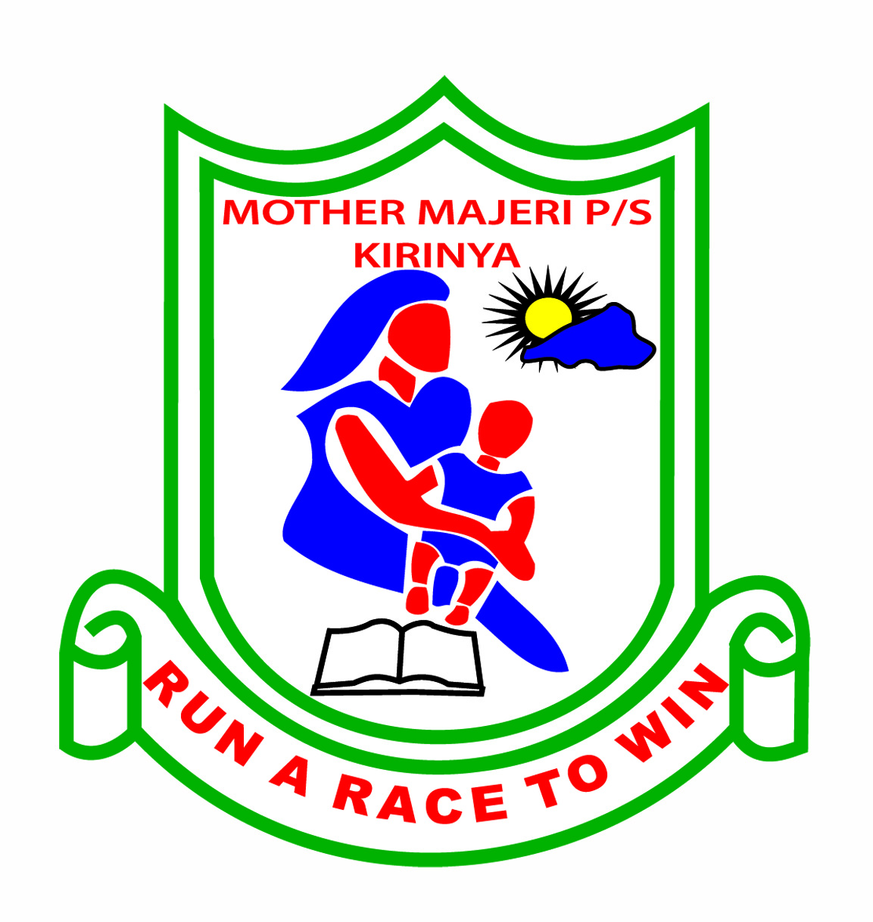**MOTHER MAJERI NURSERY SCHOOL**

**END OF TERM II EXAMINATION, 2024**

**CLASS : MIDDLE CLASS**

**AGE : 4-5 years**

**SUBJECT : ENGLISH**

**My name is :________________________________stream:_______**

**1. Match the same words.**

bird boy

ruler father

apple pencil

hut bird

pencil ruler

boy hut

father apple

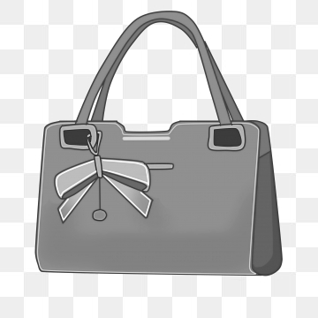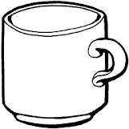**2. Write the words correctly.**

agb ________ puc ___________

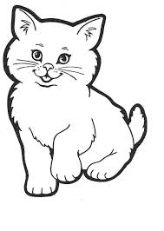

atc ________ oxb ____________

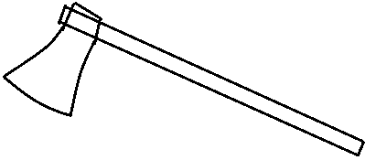

xea _________ rac _____________

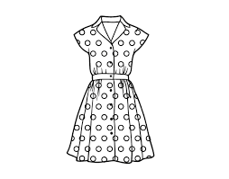**3. Read and draw.**

dress _____________ hut _____________

gun ______________ jug _____________

fan ______________ pot _____________

pen _______________

[http://t1.gstatic.com/images?q=tbn:ANd9GcTyakaYeQYDtBx0a5Vc1E40lFjKd5wU9oh_e0MP6yyxOjXrFt6Hj1lM6mA](http://www.google.co.ug/imgres?imgurl=http://www.mrs-o-c.com/ied/media/measurement/plainRuler.gif&imgrefurl=http://www.mrs-o-c.com/ied/warmupRulers.html&usg=__EP6kQzsZd_M0uHI9SNN7JI5XGDI=&h=142&w=700&sz=5&hl=en&start=6&zoom=1&tbnid=aWatOPdfq5WZlM:&tbnh=28&tbnw=140&ei=BuTRT7DhJcSKhQeG9PXtAw&prev=/search?q=rulers&hl=en&gbv=2&tbs=itp:clipart&tbm=isch&itbs=1)**4. Tick the correct word.**

ruler chalk pen



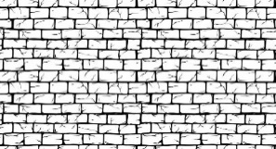

mat mug wall

[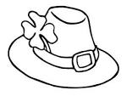](http://www.google.com/url?url=http://www.clipartbest.com/cap-coloring-pages&rct=j&frm=1&q=&esrc=s&sa=U&ved=0CBwQwW4wAjgoahUKEwiU3dzc_fPIAhXH1xQKHVgfDtg&usg=AFQjCNG9LZFCQ1wCQoWjzgcvg_bkz3691Q)

cup hat pot

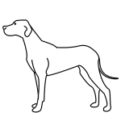

box axe dog

[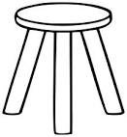](https://www.google.com/url?q=http://www.clker.com/clipart-three-legged-stool-outline.html&sa=U&ei=f9sWU9eDNeXI0wHemoHIBQ&ved=0CDAQ9QEwAA&usg=AFQjCNGLDymL8Kv25wYGlLw6rrdOS5BR2g)

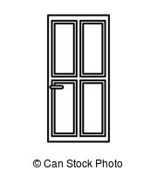 stool drum star

doll door desk

[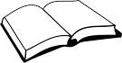](http://www.google.com/imgres?imgurl=http://pateratic.files.wordpress.com/2012/02/book.png&imgrefurl=http://pateratic.com/tag/politics-2/&usg=___7b9pCEtEDcCIYDUhmarnCuBR10=&h=309&w=600&sz=22&hl=en&start=63&zoom=1&tbnid=Yx5na8coB33FIM:&tbnh=70&tbnw=135&ei=45rvUdbkBMSn0wWZzICQDA&prev=/search?q=books&start=60&sa=N&hl=en&sout=1&biw=1341&bih=555&site=imghp&tbs=itp:clipart&tbm=isch&itbs=1&sa=X&ved=0CDIQrQMwAjg8)**5. Circle the correct word for the picture.**

book bkoo boko

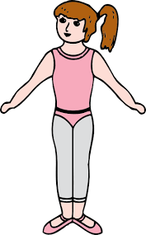

gril girl glir

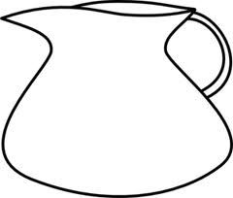

gju jgu jug

chari chair chria

mnoo mono moon

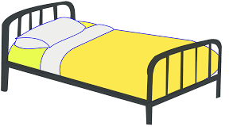

bed ebd dbe

**6. Complete the sentences.**

(a) This is a _______________.

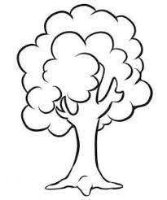

(b) This is a _______________.

(c) This is a _______________.

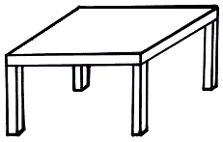

(d) This is a _______________.

[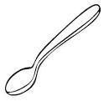](https://www.google.com/url?q=http://gallery.coloringcrew.com/jobs/cooks/spoon-colored-by-anel-19954.html&sa=U&ei=cOc8U9uSGoadtQb_s4Ew&ved=0CD4Q9QEwBw&usg=AFQjCNFNmdRD-edM4UV-JyMzmUcAOQZy_g)

(e) This is a spoon.

(f) This is a _______________.

**END**